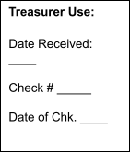
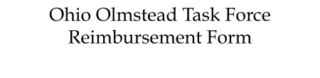
 Requests for reimbursement must be received by the first Friday of the month, following the OOTF meeting in order to be paid by month’s end.
Please send electronic form to: Jennifer Kucera, ohioolmstead@gmail.com
Or by mail to: ATTN: OOTF, 670 Morrison Road, Ste. 200, Gahanna, OH 43230

Name (Printed): | Date:
Address: | Email Address:
Name of Meeting/Event: Date(s):
Start From and Destination:

ITEM  (Receipts must be with form) | Description (Date and Amount) | Actual Expense | Approved
Mileage @ 72.5 cents per mile | Odometer Start: Odometer Stop: Total Miles: | $
Tolls and Parking |  | $
Other Transportation |  | $
Personal Attendant Services- up to $16.00 per hour if less than 12 hours or  $200 for an overnight stay (12 to 24 hour period) | “Receipt for Attendant/Driver Services”  PCA Name:  Start Date: Time:  End Date: Time:  Attendant signature; certifies that I worked these hours, I am not paid by another funder source for the same hours | $
Other |  | $
Total Reimbursement Requested |  | $
Signature:

If you have any questions, please contact Jennifer Kucera, Ohio Olmstead Task Force Chair, at ohioolmstead@gmail.com or call 440-990-5355.

Revised 2/2024

